

A white paper from Active Thermal Management
The trusted name in thermal protection…

By Frank Federman, CEO

Cooling the Built-in Cabinet – Part 2

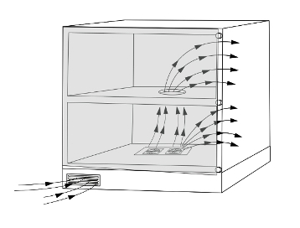
In our white paper “Cooling the Built-in Cabinet”, (available on the Downloads page at www.activethermal.com) we described a method for cooling built-in cabinets by forcing hot air out through the gaps between the doors (or between door and frame in a single door cabinet) of typical audio-video enclosures. (Figure 1) Bringing fresh “make-up” air in through a small grille installed in the cabinet’s toe-kick or up through the floor of a cabinet on legs or wall-mounted means that we would only have to make one (new) visible opening, which we can probably get the homeowner to agree to. The product that makes this possible is the ATM System 4, which includes a very powerful fan module. (Figure 2) Two stacks of three fans each produce a quiet but powerful air stream that can overcome substantial back pressure.
Figure 1
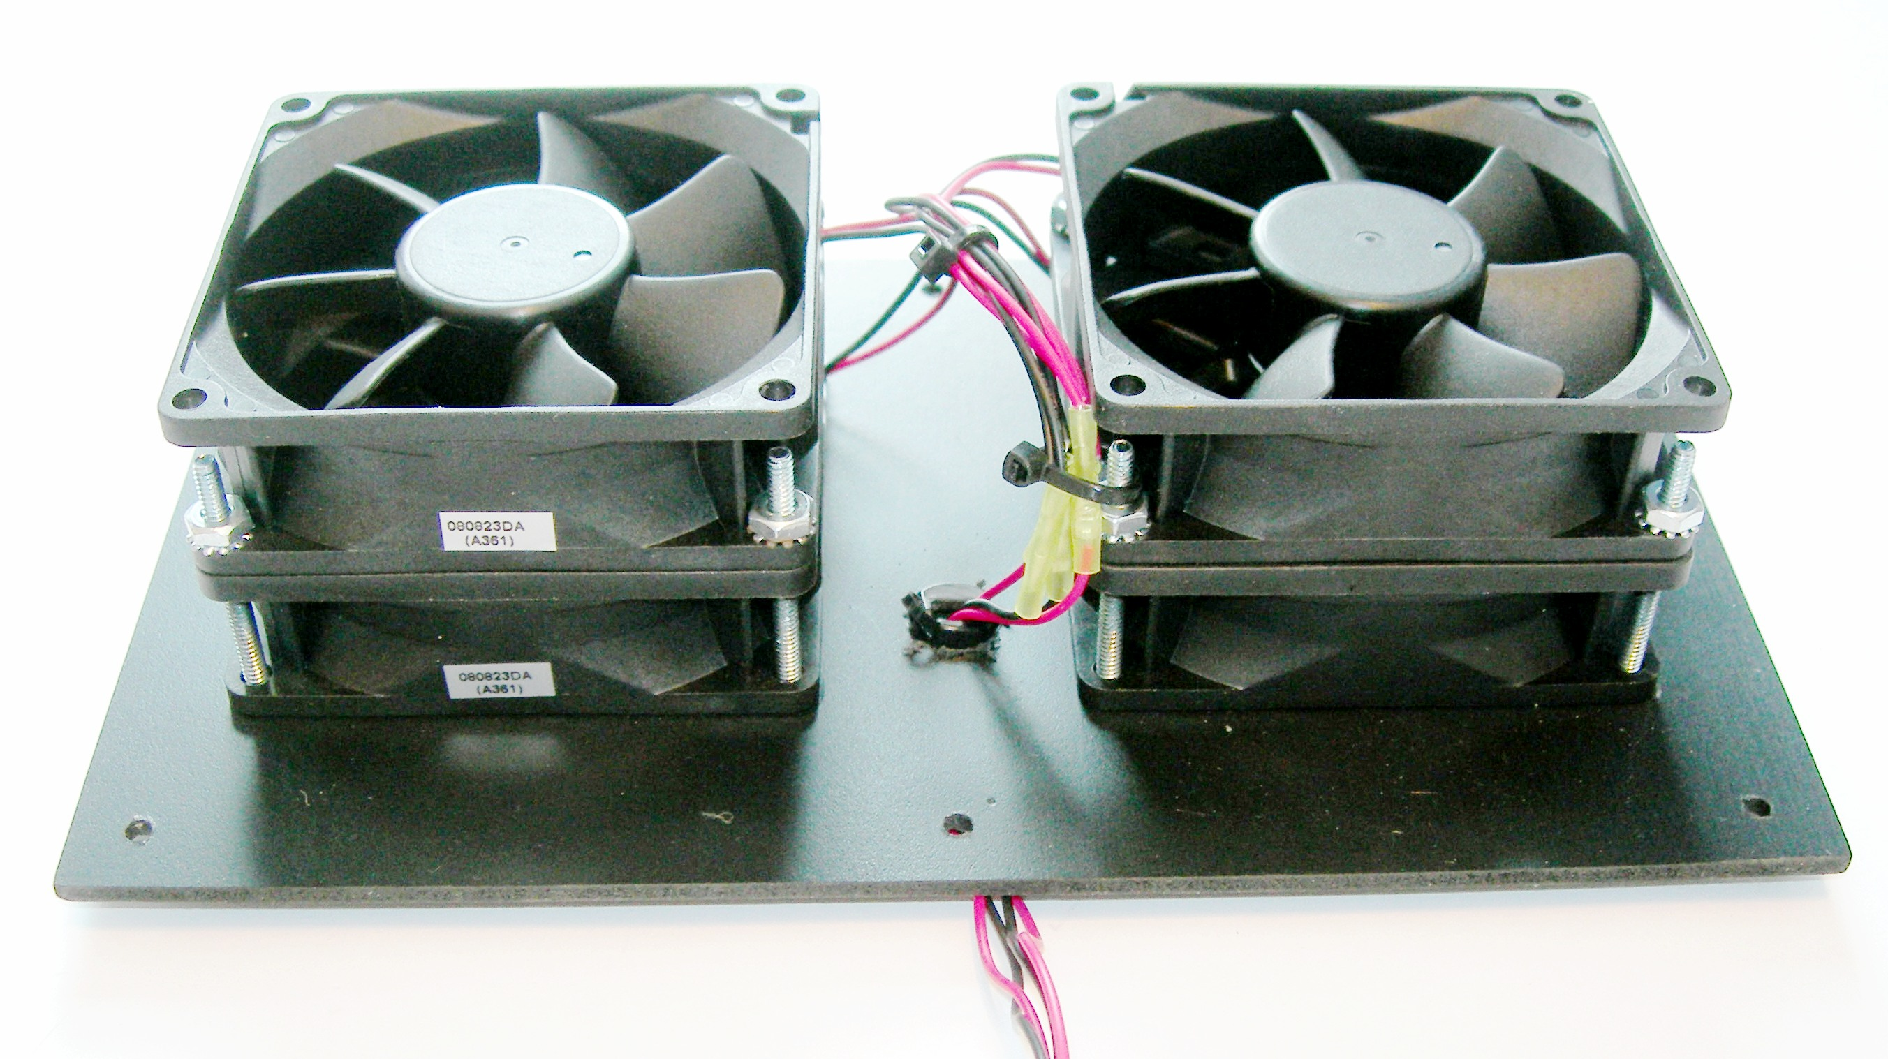
Not all cabinets have gaps large enough to allow sufficient air flow for cooling. There are other ways to ventilate built-in cabinets with few – or no - visible openings. This paper will describe two methods that should keep the equipment, the home theater enthusiast, and his wife (we tell it like it is) happy.
Figure 2

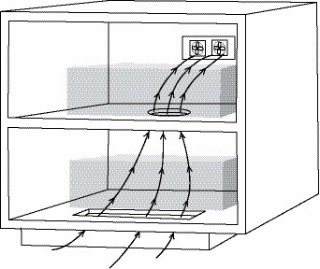
There are two types of cabinet bases. One is the recessed type as used in kitchen cabinets; the cabinet’s floor extends about 2” beyond the base (Figure 3).
Figure 3
In the other type of cabinet, the floor of the cabinet does not overhang its base; the front surface continues flush to the floor. (As shown in Figure 1)

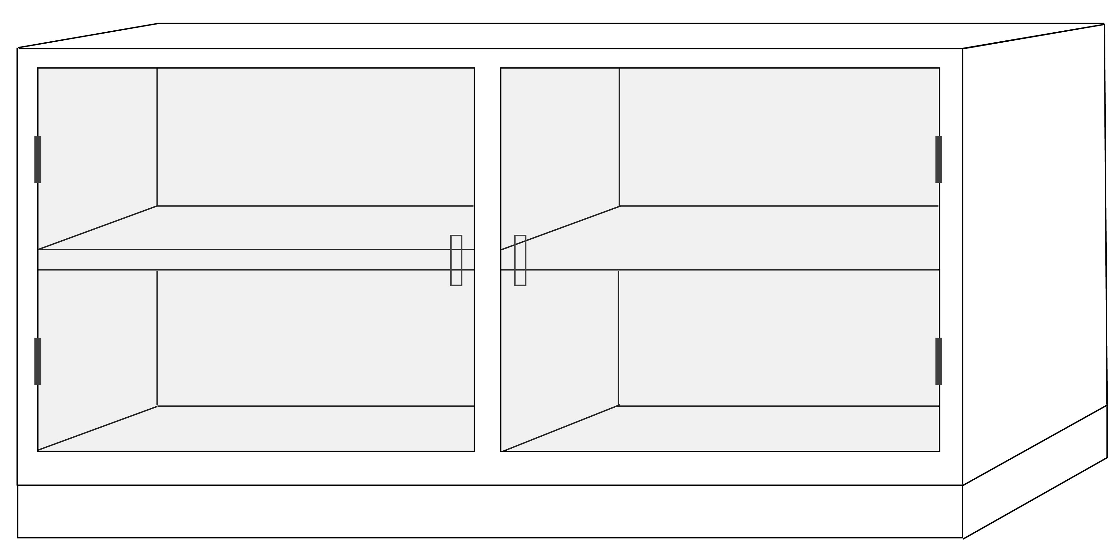
Ventilating either type of cabinet can be difficult when built-in, as the back and sides are not available for mounting fans. In most cases, the top is not available, either due to esthetic considerations or because it’s made of granite or some other “I bet you can’t cut a hole in this” material.

Many cabinets, whether built on a recessed or flush base, have double doors; some have multiple compartments, each with one or two doors. (Figure 4) We will concentrate on this popular type of cabinet, as the single compartment style was covered in the earlier paper. Whether the heat-generating equipment is in the left or right side compartment (or both), we will describe ways of moving fresh air from the room into one side, across to the other side, and then returning it to the room. Given the restrictions imposed by the nature of built-in cabinets, we will have to use the base of the cabinet for both entry and exit of the air stream.
Figure 4

Of the two types of cabinets mentioned above, those with recessed bases are the easier to ventilate. We can cut narrow openings in the cabinet’s floor just behind the doors that will be completely hidden when the doors are closed, as shown in figure 3. Typical slot dimensions are 1” wide by 10” to 15” long. (ATM can supply bezels to trim these slots – see the “Grilles & Bezels” product page at www.activethermal.com.)

Flush base cabinets are a bit more difficult, but we can make openings in the base trim and cabinet floor to bring air in under the cabinet and up into the equipment section. The openings in the base trim will be visible, so a wood or metal grille, available from Active Thermal Management, will be needed. Typical openings in base trim may be 2” wide by 7” long. Typical openings in the cabinet floor (and any shelves in the cabinet) are 4” diameter holes in the center of the floor, under the lowest piece of equipment. (It’s better to have the air flow under and around a hot component than for it to come up through an opening in the rear of the enclosure, largely bypassing the amplifier or cable box.) To keep air from recirculating, a barrier has to be put in the base separating the right section from the left. It should reach from front to back, roughly centered left-to-right, and can be installed through the fan and grille openings. Non-flammable closed-cell foam, available at fabric stores, or narrow strips of fiberglass insulation can be used to get a reasonably tight seal. If the cabinet is under construction, a barrier of wood should be used.
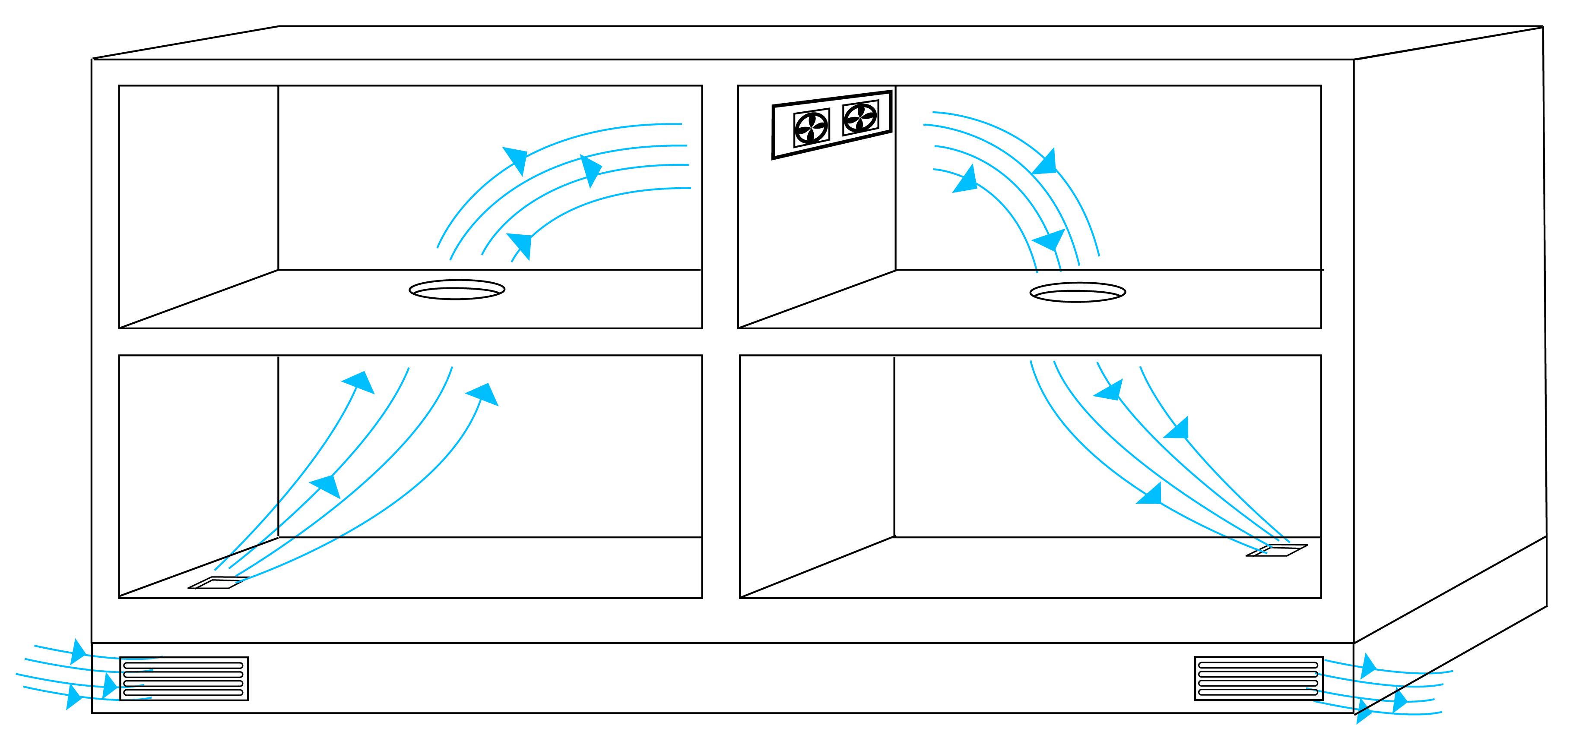
Many multi-compartment cabinets have a vertical partition separating the interior into two sections. (Figure 5) The partition is an excellent place to mount a fan system. Mounting the fans high on the partition and centered front-to-back puts them out of the way but in the best place to pull warm rising air from one side of the cabinet to the other.
Figure 5

Some multi-section cabinets may not have a vertical partition. In this case, effective cooling can be achieved by mounting the fan unit in the floor of either side, bringing fresh air in, and exhausting it through a passive opening in the floor of the other side (Figure 6). By making the passive opening the same size as required for the System 4 fan module, a second module could easily be added in the future (Figure 7) if the heat load is too high for just one fan module, or if more equipment is installed later. (Plan B – we always like to have a “Plan B”!)
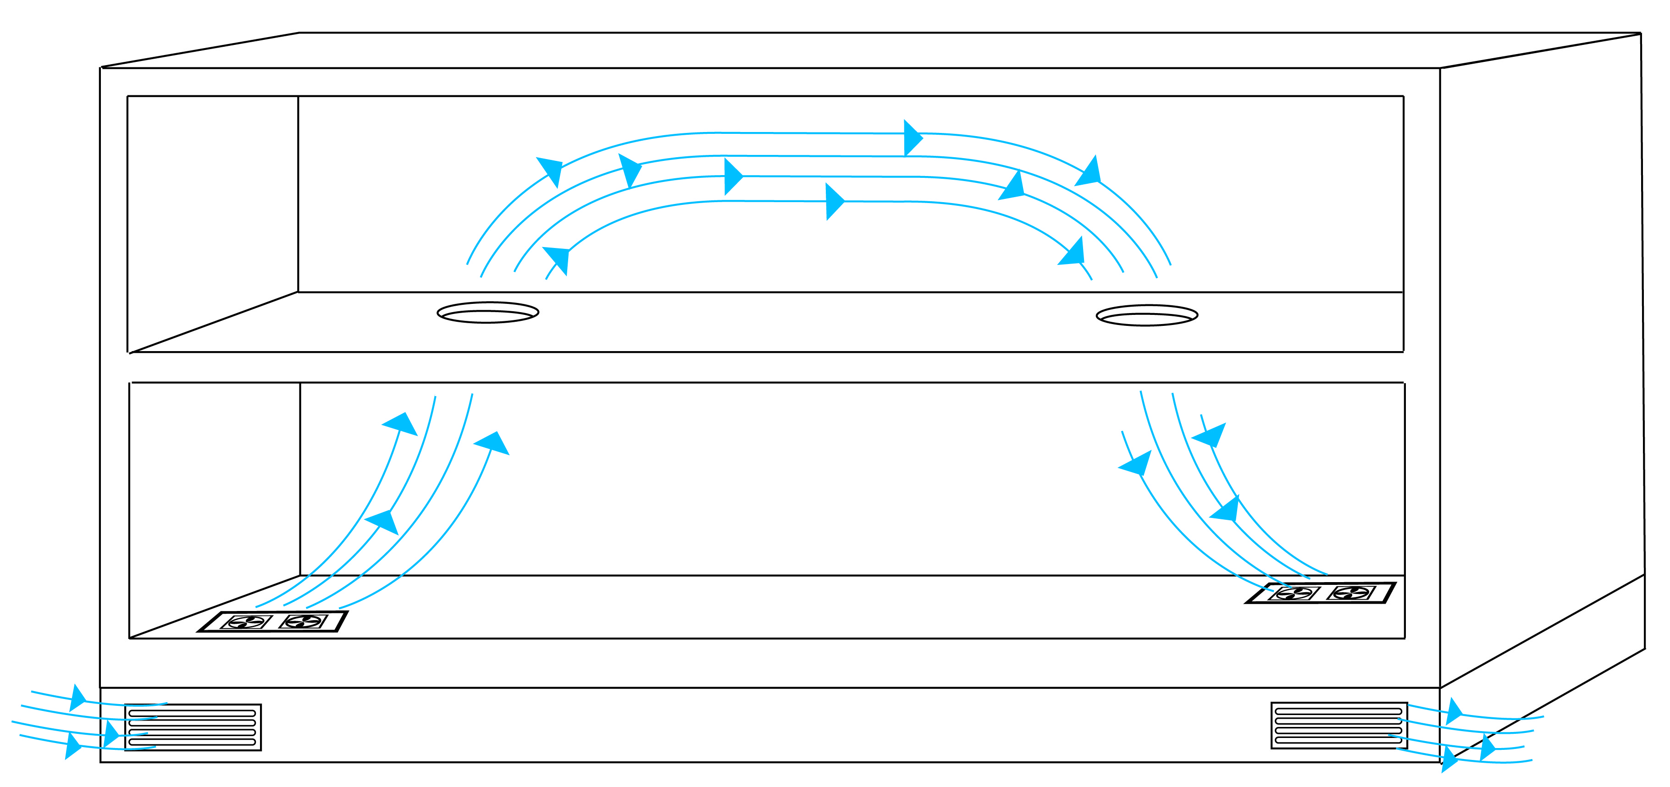
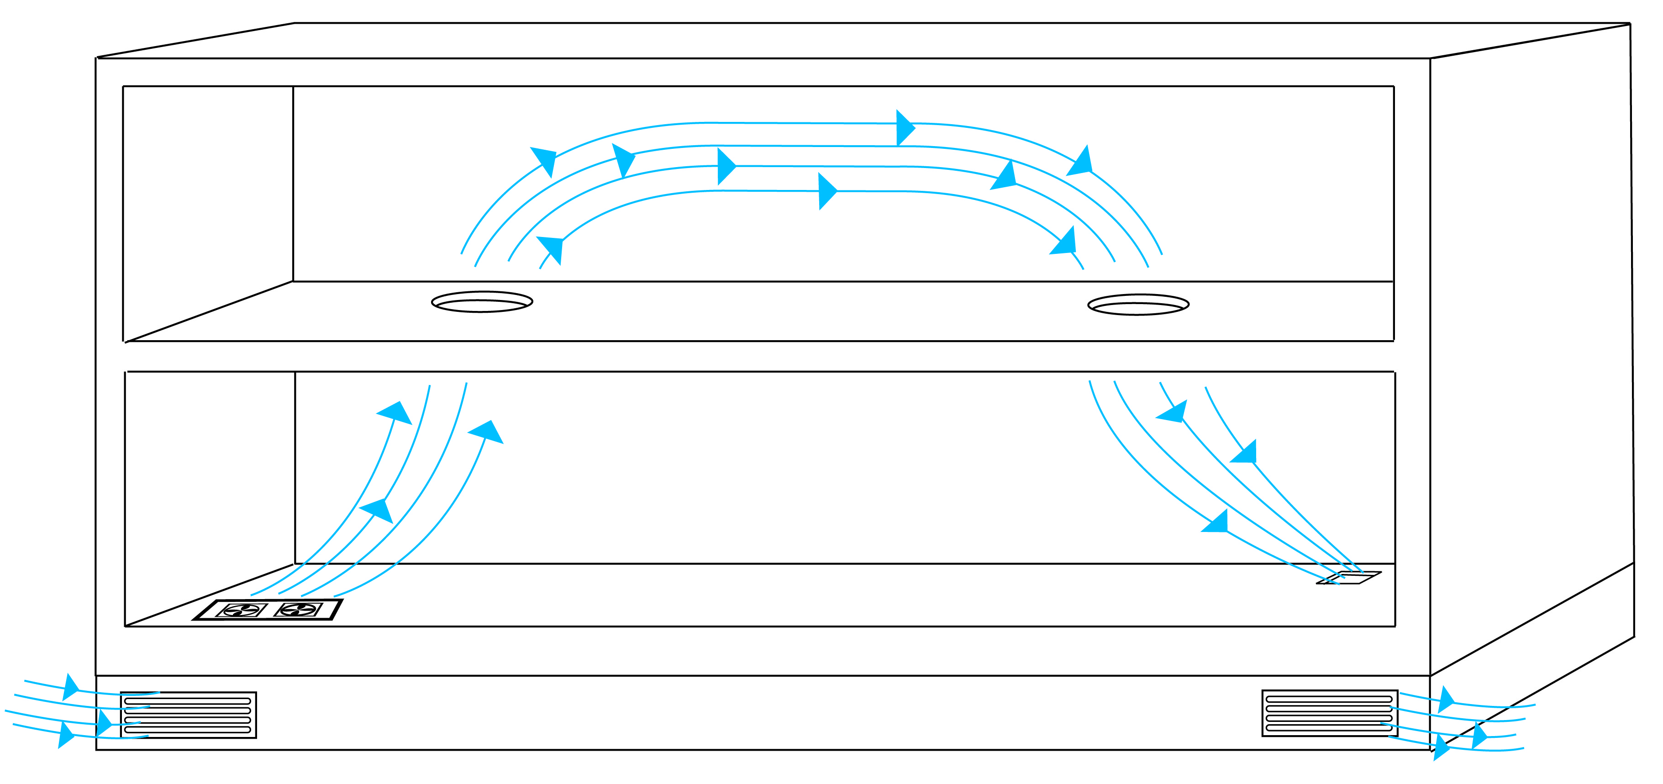

Figure 7
Figure 6

You’ll find other useful white papers on cooling various home theater and computer installations on the Downloads page at www.activethermal.com.

